What is the Process in Operating Systems
In this tutorial, we are going to learn about the Process in Operating Systems. This is the most important concept of the Operating Systems. This is very important because we would be always busy listening the word named Process everywhere in the subject named Operating System.
The main duty or the work of the Operating System is to complete the given process in less than the given stipulated time. So, the term process is very important for the subject named Operating Systems. Now, let us learn everything about the term process in a very deep manner.

Definition of Process
Basically, a process is a simple program.
An active program which running now on the Operating System is known as the process. The Process is the base of all computing things. Although process is relatively similar to the computer code but, the method is not the same as computer code. A process is a "active" entity, in contrast to the program, which is sometimes thought of as some sort of "passive" entity. The properties that the process holds include the state of the hardware, the RAM, the CPU, and other attributes.

Process in an Operating System
A process is actively running software or a computer code. Any procedure must be carried out in a precise order. An entity that helps in describing the fundamental work unit that must be implemented in any system is referred to as a process.
In other words, we create computer programs as text files that, when executed, create processes that carry out all of the tasks listed in the program.
When a program is loaded into memory, it may be divided into the four components stack, heap, text, and data to form a process. The simplified depiction of a process in the main memory is shown in the diagram below.
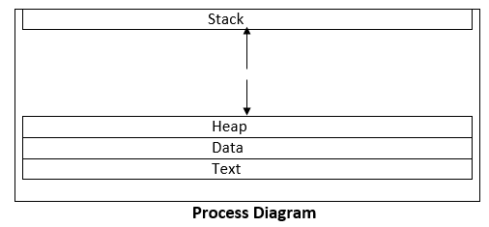

Stack
The process stack stores temporary information such as method or function arguments, the return address, and local variables.
Heap
This is the memory where a process is dynamically allotted while it is running.
Text
This consists of the information stored in the processor's registers as well as the most recent activity indicated by the program counter's value.
Data
In this section, both global and static variables are discussed.

Program
Program is a set of instructions which are executed when the certain task is allowed to complete that certain task. The programs are usually written in a Programming Language like C, C ++, Python, Java, R, C # (C sharp), etc.
A computer program is a set of instructions that, when carried out by a computer, accomplish a certain task

Difference between process and the program
S. No | Process | Program
1 | A process is actively running software or a computer code. Any procedure must be carried out in a precise order. An entity that helps in describing the fundamental work unit that must be implemented in any system is referred to as a process | Program is a set of instructions which are executed when the certain task is allowed to complete that certain task
2 | Process is Dynamic in Nature | Program is Static in Nature
3 | Process is an Active in Nature | Program is Passive in Nature
4 | Process is created during the execution and it is loaded directly into the main memory | Program is already existed in the memory and it is present in the secondary memory.
5 | Process has its own control system known as Process Control Block | Program does not have any control system. It is just called when specified and it executes the whole program when called
6 | Process changes from time to time by itself | Program cannot be changed on its own. It must be changed by the programmer.
7 | A process needs extra data in addition to the program data needed for management and execution. | Program is basically divided into two parts. One is Code part and the other part is data part.
8 | Processes have significant resource demands; they require resources like Memory Addresses, Central Processing Unit, Input or Output until their presence or existence in the Operating System. | A program just needs memory space to store its instructions; no further resources are needed.

Process Control Block
An Operating System helps in process creation, scheduling, and termination with the help of Process Control Block. The Process Control Block (PCB), which is part of the Operating System, aids in managing how processes operate. Every OS process has a Process Control Block related to it. By keeping data on different things including their state, I/O status, and CPU Scheduling, a PCB maintains track of processes.
Now, let us understand the Process Control Block with the help of the components present in the Process Control Block.
A Process Control Block consists of :
- Process ID
- Process State
- Program Counter
- CPU Registers
- CPU Scheduling Information
- Accounting and Business Information
- Memory Management Information
- Input Output Status Information
Now, let us understand about each and every component in detail now.
1) Process ID
It is a Identification mark which is present for the Process. This is very useful for finding the process. It is also very useful for identifying the process also.
2) Process State

Now, let us know about each and every process states in detail. Let me explain about each and every state
i) New State
A Program which is going to be taken up by the Operating System directly into the Main Memory is known as a New Process State
ii) Ready State
The ready state, when a process waits for the CPU to be assigned, is the first state it enters after being formed. The operating system pulls new processes from secondary memory and places them all in main memory.
The term "ready state processes" refers to processes that are in the main memory and are prepared for execution. Numerous processes could be active at the moment.
iii) Running State
The Operating System will select one of the processes from the ready state based on the scheduling mechanism. As a result, if our system only has one CPU, there will only ever be one process operating at any given moment. We can execute n processes concurrently in the system if there are n processors.
iv) Waiting or Blocking State
Depending on the scheduling mechanism or the inherent behavior of the process, a process can go from the Running state to the Block or Wait states.
The OS switches a process to the block or wait state and allots the CPU to the other processes while it waits for a specific resource to be allocated or for user input.
v) Terminated State
A process enters the termination state once it has completed its execution. The operating system will end the process and erase the whole context of the process (Process Control Block).
3) Program Counter
The address of the following instruction to be executed from memory is stored in a CPU register called a program counter (PC) in the computer processor. It is a digital counter required for both task execution speed and for monitoring the present stage of execution.
An instruction counter, instruction pointer, instruction addresses register, or sequence control register are other names for a program counter.
4) CPU Registers
When the process is in a running state, here is where the contents of the processor registers are kept. Accumulators, index and general-purpose registers, instruction registers, and condition code registers are the many categories of CPU registers.
5) CPU Scheduling Information
It is necessary to arrange a procedure for execution. This schedule determines when it transitions from ready to running. Process priority, scheduling queue pointers (to indicate the order of execution), and several other scheduling parameters are all included in CPU scheduling information.
6) Accounting and Business Information
The State of Business Addressing and Information includes information such as CPU use, the amount of time a process uses in real time, the number of jobs or processes, etc.
7) Memory Management Information
The Memory Management Information section contains information on the page, segment tables, and the value of the base and limit registers. It relies on the operating system's memory system.
8) Input Output Status Information
This Input Output Status Information section consists of Input and Output related information which includes about the process statuses, etc.

Process Scheduling in OS (Operating System)
Operating system uses various schedulers for the process scheduling described below.

1. Long term scheduler
Long term scheduler is also known as job scheduler. It chooses the processes from the pool (secondary memory) and keeps them in the ready queue maintained in the primary memory.
Long Term scheduler mainly controls the degree of Multiprogramming. The purpose of long term scheduler is to choose a perfect mix of IO bound and CPU bound processes among the jobs present in the pool.
If the job scheduler chooses more IO bound processes then all of the jobs may reside in the blocked state all the time and the CPU will remain idle most of the time. This will reduce the degree of Multiprogramming. Therefore, the Job of long term scheduler is very critical and may affect the system for a very long time.

2. Short term scheduler
Short term scheduler is also known as CPU scheduler. It selects one of the Jobs from the ready queue and dispatch to the CPU for the execution.
A scheduling algorithm is used to select which job is going to be dispatched for the execution. The Job of the short term scheduler can be very critical in the sense that if it selects job whose CPU burst time is very high then all the jobs after that, will have to wait in the ready queue for a very long time.
This problem is called starvation which may arise if the short term scheduler makes some mistakes while selecting the job.

3. Medium term scheduler
Medium term scheduler takes care of the swapped out processes.If the running state processes needs some IO time for the completion then there is a need to change its state from running to waiting.
Medium term scheduler is used for this purpose. It removes the process from the running state to make room for the other processes. Such processes are the swapped out processes and this procedure is called swapping. The medium term scheduler is responsible for suspending and resuming the processes.
It reduces the degree of multiprogramming. The swapping is necessary to have a perfect mix of processes in the ready queue.

Process Queues
The Operating system manages various types of queues for each of the process states. The PCB related to the process is also stored in the queue of the same state. If the Process is moved from one state to another state then its PCB is also unlinked from the corresponding queue and added to the other state queue in which the transition is made.
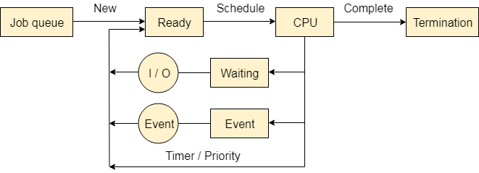
There are the following queues maintained by the Operating system.

1. Job Queue
In starting, all the processes get stored in the job queue. It is maintained in the secondary memory. The long term scheduler (Job scheduler) picks some of the jobs and put them in the primary memory.

2. Ready Queue
Ready queue is maintained in primary memory. The short term scheduler picks the job from the ready queue and dispatch to the CPU for the execution.

3. Waiting Queue
When the process needs some IO operation in order to complete its execution, OS changes the state of the process from running to waiting. The context (PCB) associated with the process gets stored on the waiting queue which will be used by the Processor when the process finishes the IO.

What is Inter Process Communication?
In general, Inter Process Communication is a type of mechanism usually provided by the operating system (or OS). The main aim or goal of this mechanism is to provide communications in between several processes. In short, the intercommunication allows a process letting another process know that some event has occurred.
Let us now look at the general definition of inter-process communication, which will explain the same thing that we have discussed above.

Definition
"Inter-process communication is used for exchanging useful information between numerous threads in one or more processes (or programs)."
To understand inter process communication, you can consider the following given diagram that illustrates the importance of inter-process communication:
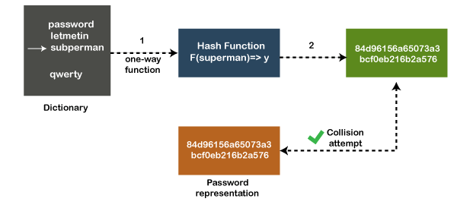

Role of Synchronization in Inter Process Communication
It is one of the essential parts of inter process communication. Typically, this is provided by interprocess communication control mechanisms, but sometimes it can also be controlled by communication processes.
These are the following methods that used to provide the synchronization:
- Mutual Exclusion
- Semaphore
- Barrier
- Spinlock
Mutual Exclusion:-
It is generally required that only one process thread can enter the critical section at a time. This also helps in synchronization and creates a stable state to avoid the race condition.
Semaphore:-
Semaphore is a type of variable that usually controls the access to the shared resources by several processes. Semaphore is further divided into two types which are as follows:
- Binary Semaphore
- Counting Semaphore
Barrier:-
A barrier typically not allows an individual process to proceed unless all the processes does not reach it. It is used by many parallel languages, and collective routines impose barriers.
Spinlock:-
Spinlock is a type of lock as its name implies. The processes are trying to acquire the spinlock waits or stays in a loop while checking that the lock is available or not. It is known as busy waiting because even though the process active, the process does not perform any functional operation (or task).

Approaches to Interprocess Communication
We will now discuss some different approaches to inter-process communication which are as follows:
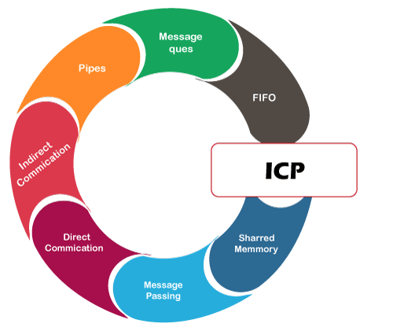
These are a few different approaches for Inter- Process Communication:
- Pipes
- Shared Memory
- Message Queue
- Direct Communication
- Indirect communication
- Message Passing
- FIFO
To understand them in more detail, we will discuss each of them individually.
Pipe:-
The pipe is a type of data channel that is unidirectional in nature. It means that the data in this type of data channel can be moved in only a single direction at a time. Still, one can use two-channel of this type, so that he can able to send and receive data in two processes. Typically, it uses the standard methods for input and output. These pipes are used in all types of POSIX systems and in different versions of window operating systems as well.
Shared Memory:-
It can be referred to as a type of memory that can be used or accessed by multiple processes simultaneously. It is primarily used so that the processes can communicate with each other. Therefore the shared memory is used by almost all POSIX and Windows operating systems as well.
Message Queue:-
In general, several different messages are allowed to read and write the data to the message queue. In the message queue, the messages are stored or stay in the queue unless their recipients retrieve them. In short, we can also say that the message queue is very helpful in inter-process communication and used by all operating systems.
To understand the concept of Message queue and Shared memory in more detail, let's take a look at its diagram given below:
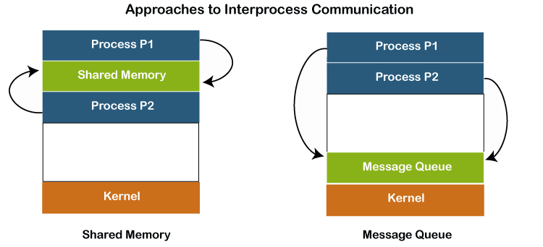
Message Passing:-
It is a type of mechanism that allows processes to synchronize and communicate with each other. However, by using the message passing, the processes can communicate with each other without restoring the hared variables.
Usually, the inter-process communication mechanism provides two operations that are as follows:
- send (message)
- re
- ceived (message)

Note: The size of the message can be fixed or variable.
Direct Communication:-
In this type of communication process, usually, a link is created or established between two communicating processes. However, in every pair of communicating processes, only one link can exist.
Indirect Communication
Indirect communication can only exist or be established when processes share a common mailbox, and each pair of these processes shares multiple communication links. These shared links can be unidirectional or bi-directional.
FIFO:-
It is a type of general communication between two unrelated processes. It can also be considered as full-duplex, which means that one process can communicate with another process and vice versa.

Some other different approaches
- Socket:-
It acts as a type of endpoint for receiving or sending the data in a network. It is correct for data sent between processes on the same computer or data sent between different computers on the same network. Hence, it used by several types of operating systems.
- File:-
A file is a type of data record or a document stored on the disk and can be acquired on demand by the file server. Another most important thing is that several processes can access that file as required or needed.
- Signal:-
As its name implies, they are a type of signal used in inter process communication in a minimal way. Typically, they are the massages of systems that are sent by one process to another. Therefore, they are not used for sending data but for remote commands between multiple processes.
Usually, they are not used to send the data but to remote commands in between several processes.

Why we need interprocess communication?
There are numerous reasons to use inter-process communication for sharing the data. Here are some of the most important reasons that are given below:
- It helps to speedup modularity
- Computational
- Privilege separation
- Convenience
- Helps operating system to communicate with each other and synchronize their actions as well.

IPC through Shared Memory
Shared memory is a memory shared between two or more processes. Each process has its own address space; if any process wants to communicate with some information from its own address space to other processes, then it is only possible with IPC (inter-process communication) techniques.
Shared memory is the fastest inter-process communication mechanism. The operating system maps a memory segment in the address space of several processes to read and write in that memory segment without calling operating system functions.
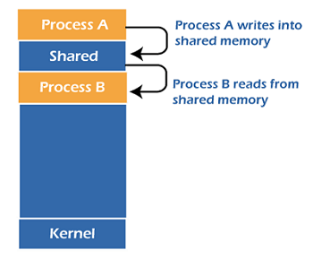
For applications that exchange large amounts of data, shared memory is far superior to message passing techniques like message queues, which require system calls for every data exchange. To use shared memory, we have to perform two basic steps:
- Request a memory segment that can be shared between processes to the operating system.
- Associate a part of that memory or the whole memory with the address space of the calling process.
A shared memory segment is a portion of physical memory that is shared by multiple processes. In this region, processes can set up structures, and others may read/write on them. When a shared memory region is established in two or more processes, there is no guarantee that the regions will be placed at the same base address. Semaphores can be used when synchronization is required.
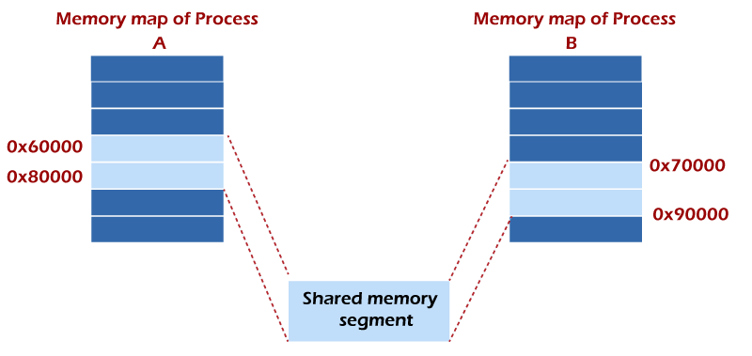
For example, one process might have the shared region starting at address 0x60000 while the other process uses 0x70000. It is critical to understand that these two addresses refer to the exact same piece of data. So storing the number 1 in the first process's address 0x60000 means the second process has the value of 1 at 0x70000. The two different addresses refer to the exact same location.

Why Choose IPC through Shared Memory
Usually, inter-related process communication is performed using Pipes or Named Pipes. And unrelated processes communication can be performed using Named Pipes or through popular IPC techniques of Shared Memory and Message Queues.
But the problem with pipes, FIFO, and message queue is that the information exchange between two processes goes through the kernel, and it works as follows.
- The server reads from the input file.
- The server writes this data in a message using pipe, FIFO, or message queue.
- The client reads the data from the IPC channel, again requiring the data to be copied from the kernel's IPC buffer to the client's buffer.
- Finally, the data is copied from the client's buffer.
A total of four copies of data are required (2 read and 2 write). So, shared memory provides a way by letting two or more processes share a memory segment. With Shared Memory, the data is only copied twice, from the input file into shared memory and from shared memory to the output file.

Functions of IPC Using Shared Memory
Two functions shmget() and shmat() are used for IPC using shared memory. shmget() function is used to create the shared memory segment, while the shmat() function is used to attach the shared segment with the process's address space.
1. shmget() Function
The first parameter specifies the unique number (called key) identifying the shared segment. The second parameter is the size of the shared segment, e.g., 1024 bytes or 2048 bytes. The third parameter specifies the permissions on the shared segment. On success, the shmget() function returns a valid identifier, while on failure, it returns -1.
Syntax
- #include <sys/ipc.h>
- #include <sys/shm.h>
- int shmget (key_t key, size_t size, int shmflg);
2. shmat() Function
shmat() function is used to attach the created shared memory segment associated with the shared memory identifier specified by shmid to the calling process's address space. The first parameter here is the identifier which the shmget() function returns on success. The second parameter is the address where to attach it to the calling process. A NULL value of the second parameter means that the system will automatically choose a suitable address. The third parameter is '0' if the second parameter is NULL. Otherwise, the value is specified by SHM_RND.
Syntax
- #include <sys/types.h>
- #include <sys/shm.h>
- void *shmat(int shmid, const void *shmaddr, int shmflg);

How does IPC Using Shared Memory work?
A process creates a shared memory segment using shmget(). The original owner of a shared memory segment can assign ownership to another user with shmctl(). It can also revoke this assignment. Other processes with proper permission can perform various control functions on the shared memory segment using shmctl().
Once created, a shared segment can be attached to a process address space using shmat(). It can be detached using shmdt(). The attaching process must have the appropriate permissions for shmat(). Once attached, the process can read or write to the segment, as the permission requested in the attach operation allows. A shared segment can be attached multiple times by the same process.
A shared memory segment is described by a control structure with a unique ID that points to an area of physical memory. The identifier of the segment is called the shmid. The structure definition for the shared memory segment control structures and prototypes can be found in <sys/shm.h>.

Examples
We will write two programs for IPC using shared memory as an example. Program 1 will create the shared segment, attach it, and then write some content in it. Then Program 2 will attach itself to the shared segment and read the value written by Program 1.
Program 1: This program creates a shared memory segment, attaches itself to it, and then writes some content into the shared memory segment.
- #include<stdio.h>
- #include<stdlib.h>
- #include<unistd.h>
- #include<sys/shm.h>
- #include<string.h>
- int main()
- {
- int i;
- void *shared_memory;
- char buff[100];
- int shmid;
- shmid=shmget((key_t)2345, 1024, 0666|IPC_CREAT);
- //creates shared memory segment with key 2345, having size 1024 bytes. IPC_CREAT is used to create the shared segment if it does not exist. 0666 are the permissions on the shared segment
- printf("Key of shared memory is %d\n",shmid);
- shared_memory=shmat(shmid,NULL,0);
- //process attached to shared memory segment
- printf("Process attached at %p\n",shared_memory);
- //this prints the address where the segment is attached with this process
- printf("Enter some data to write to shared memory\n");
- read(0,buff,100); //get some input from user
- strcpy(shared_memory,buff); //data written to shared memory
- printf("You wrote : %s\n",(char *)shared_memory);
- }
Output
Key of shared memory is 0
Process attached at 0x7ffe040fb000
Enter some data to write to shared memory
Hello World
You wrote: Hello World
How does it work?
In the above program, the shmget() function creates a segment with key 2345, size 1024 bytes, and reads and writes permissions for all users. It returns the identifier of the segment, which gets stored in shmid. This identifier is used in shmat() to attach the shared segment to the process's address space.
NULL in shmat() means that the OS will itself attach the shared segment at a suitable address of this process. Then some data is read from the user using the read() system call, and it is finally written to the shared segment using the strcpy() function.
Program 2: This program attaches itself to the shared memory segment created in Program 1, and it reads the content of the shared memory.
- #include<stdio.h>
- #include<stdlib.h>
- #include<unistd.h>
- #include<sys/shm.h>
- #include<string.h>
- int main()
- {
- int i;
- void *shared_memory;
- char buff[100];
- int shmid;
- shmid=shmget((key_t)2345, 1024, 0666);
- printf("Key of shared memory is %d\n",shmid);
- shared_memory=shmat(shmid,NULL,0); //process attached to shared memory segment
- printf("Process attached at %p\n",shared_memory);
- printf("Data read from shared memory is : %s\n",(char *)shared_memory);
- }
Output
Key of shared memory is 0
Process attached at 0x7f76b4292000
Data read from shared memory is: Hello World
How does it work?
In this program, shmget() here generates the identifier of the same segment as created in Program 1. Remember to give the same key value. The only change is, do not write IPC_CREAT as the shared memory segment is already created. Next, shmat() attaches the shared segment to the current process.
After that, the data is printed from the shared segment. In the output, you will see the same data that you have written while executing Program 1.

Difference between Shared Memory and Message Passing in Operating System
In this article, you will learn the difference between shared memory and memory passing. But before discussing the differences, you must know about the shared memory and message passing.

What is Shared Memory?
The fundamental model of inter-process communication is the shared memory system. In a shared memory system, the collaborating communicates with each other by establishing the shared memory region in the address space region.
If the process wishes to initiate communication and has data to share, create a shared memory region in its address space. After that, if another process wishes to communicate and tries to read the shared data, it must attach to the starting process's shared address space.

What is Message Passing?
In this message passing process model, the processes communicate with others by exchanging messages. A communication link between the processes is required for this purpose, and it must provide at least two operations: transmit (message) and receive (message). Message sizes might be flexible or fixed.

Key differences between the Shared Memory and Message Passing

Here, you will learn the various key differences between Shared Memory and Message Passing. Various differences between Shared Memory and Message Passing are as follows:
- Shared memory is used to communicate between the single processor and multiprocessor systems. The communication processes are on the same machine and share the same address space. On the other hand, message passing is most commonly utilized in a distributed setting when communicating processes are spread over multiple devices linked by a network.
- Shared memory offers a maximum computation speed because communication is completed via the shared memory, so the system calls are only required to establish the shared memory. On the other hand, message passing takes time because it is performed via the kernel (system calls).
- The shared memory region is mainly used for data communication. On the other hand, message passing is mainly used for communication.
- Make sure that processes in shared memory aren't writing to the same address simultaneously. On the other hand, message passing is useful for sharing little quantities of data without causing disputes.
- The code for reading and writing the data from the shared memory should be written explicitly by the developer. On the other hand, no such code is required in this case because the message passing feature offers a method for communication and synchronization of activities executed by the communicating processes.

Head-to-head comparison between Shared Memory the Message Passing
Here, you will learn the head-to-head comparisons between the Shared Memory and the Message Passing. The main differences between the Shared Memory and the Message Passing are as follows:

Shared Memory | Message Passing
It is mainly used for data communication. | It is mainly used for communication.
It offers a maximum speed of computation because communication is completed via the shared memory, so the system calls are only required to establish the shared memory. | It takes a huge time because it is performed via the kernel (system calls).
The code for reading and writing the data from the shared memory should be written explicitly by the developer. | No such code is required in this case because the message passing feature offers a method for communication and synchronization of activities executed by the communicating processes.
It is used to communicate between the single processor and multiprocessor systems in which the processes to be communicated are on the same machine and share the same address space. | It is most commonly utilized in a distributed setting when communicating processes are spread over multiple devices linked by a network.
It is a faster communication strategy than the message passing. | It is a relatively slower communication strategy than the shared memory.
Make sure that processes in shared memory aren't writing to the same address simultaneously. | It is useful for sharing little quantities of data without causing disputes.

Difference between User level and Kernel level threads in Operating System
In this article, you will learn about the difference between the user and Kernel level threads. But before discussing the differences, you must know about the user and Kernel level threads and their advantages and disadvantages.

What is User Level Thread?
The User-level threads are small and faster as compared to kernel-level threads, and the OS directly supports user-level threads. Users implement the user-level threads, and the kernel is unaware of their existence and handles them as though they are single-threaded processes. These threads are represented by registers, the program counter (PC), stack, and some small process control. Furthermore, there is no kernel interaction in user-level thread synchronization.
It is also known as the many-to-one mapping thread, as the OS assigns every thread in a multithreaded program to an execution context. Every multithreaded process is treated as a single execution unit by the OS.

Advantages and Disadvantages of User Level Threads
There are various advantages and disadvantages of User-level Threads. Some of the advantages and disadvantages of User-level Threads are as follows:
Advantages
- User level threads are simpler and faster to generate. They are also easier to manage.
- Thread switching in user-level threads doesn't need kernel mode privileges.
- These are more portable.
- These threads may be run on any OS.
Disadvantages
- The complete process is blocked if a user-level thread runs a blocking operation.
- User-level threads don't support system-wide scheduling priorities.
- It is not appropriate for a multiprocessor system.

What are Kernel Level Threads?
In Kernel Level Thread, the kernel handles all thread management. Every process doesn't have a thread table, but the kernel has one that maintains track of all of the threads in the system. If a thread wishes to make a new thread or stop an existing one, it initiates a kernel call that performs the work.
The kernel-level threads table contains each thread's registers, status, and other information. The data is identical to that of user-level threads, except it is now in kernel space rather than user space.

Advantages and Disadvantages of Kernel Level Threads
There are various advantages and disadvantages of kernel-level Threads. Some of the advantages and disadvantages of Kernel-level Threads are as follows:
Advantages
- If a thread in the kernel is blocked, it does not block all other threads in the same process.
- Several threads of the same process might be scheduled on different CPUs in kernel-level threading.
- Kernel routines can be multithreaded as well.
Disadvantages
- Compared to user-level threads, kernel-level threads take longer to create and maintain.
- A mode switch to kernel mode is important to transfer control from one thread in a process to another.

Main differences between the User Level Threads and Kernel Level Threads

Here, you will learn the main differences between the User Level and Kernel Level Threads in the operating system. The operating system has various differences between the User Level and Kernel Level Threads are as follows:
- Users implement the user-level threads. On the other hand, the OS implements kernel-level threads.
- User-level threads may be created and handled much faster. In contrast, kernel-level threads take longer to create and maintain.
- The entire process is halted if a single user-level thread carries out a blocking operation. On the other hand, if a kernel thread carries out a blocking operation, another thread may continue to run.
- The user-level thread library includes the source code for thread creation, data transfer, thread destruction, message passing, and thread scheduling. On the other hand, the application code on kernel-level threads does not include thread management code. It is simply an API to the kernel mode.
- User-level threads do not invoke system calls for scheduling. On the other hand, system calls are used to generate and manage threads at the kernel level.
- The user-level thread is also referred to as the many-to-one mapping thread, as the OS assigns each thread in a multithreaded process to an execution context. On the other hand, One-to-one thread mapping is supported at the kernel level. Each user thread must be assigned to a kernel thread. This mapping is handled by the OS.
- Context switch time is less in the user-level threads. On the other hand, context switch time is more in kernel-level threads.
- User-level threads may operate on any OS. In contrast, kernel-level threads are specific to the OS.
- Multithread applications are unable to employ multiprocessing in user-level threads. In contrast, Kernel-level threads may be multithreaded.
- Some instances of user-level threads are Java threads and POSIX threads. On the other hand, some instances of Kernel-level threads are Windows and Solaris.

Head-to-head comparison between the User level threads and Kernel level threads
Here, you will learn the head-to-head comparison between the User Level and Kernel Level Threads in the operating system. The operating system has various differences between the User Level and Kernel Level Threads are as follows:
Features | User Level Threads | Kernel Level Threads
Implemented by | It is implemented by the users. It is implemented by the OS.
Context switch time | Its time is less. | Its time is more.
Multithreading | Multithread applications are unable to employ multiprocessing in user-level threads. | It may be multithreaded.
Implementation | It is easy to implement. | It is complicated to implement.
Blocking Operation | If a thread in the kernel is blocked, it blocks all other threads in the same process. | If a thread in the kernel is blocked, it does not block all other threads in the same process.
Recognize | OS doesn't recognize it. | It is recognized by OS.
Thread Management | Its library includes the source code for thread creation, data transfer, thread destruction, message passing, and thread scheduling. | The application code on kernel-level threads does not include thread management code, and it is simply an API to the kernel mode.
Hardware Support | It doesn't need hardware support. | It requires hardware support.
Creation and Management | It may be created and managed much faster. | It takes much time to create and handle.
Examples | Some instances of user-level threads are Java threads and POSIX threads. | Some instances of Kernel-level threads are Windows and Solaris.
Operating System | Any OS may support it. | The specific OS may support it.

Conclusion
In summary, the primary distinction between User Level Threads and Kernel Level Threads is that the user maintains User Level Threads. In contrast, the kernel-level threads are handled by the OS. All modern OS supports the threading model, and the implementation of a thread will vary depending on the OS.

Multithreading Models in Operating system
In this article, we will understand the multithreading model in the Operating system.

Multithreading Model:
Multithreading allows the application to divide its task into individual threads. In multi-threads, the same process or task can be done by the number of threads, or we can say that there is more than one thread to perform the task in multithreading. With the use of multithreading, multitasking can be achieved.
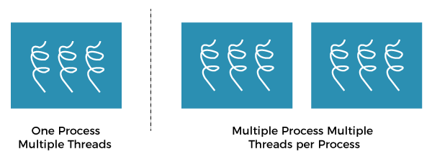
The main drawback of single threading systems is that only one task can be performed at a time, so to overcome the drawback of this single threading, there is multithreading that allows multiple tasks to be performed.
For example:
Backward Skip 10sPlay VideoForward Skip 10s
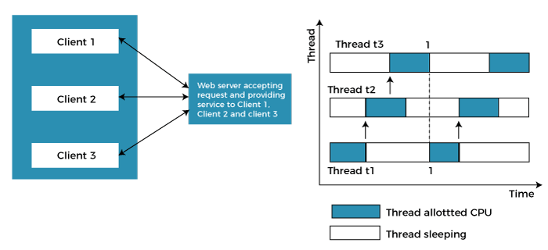
In the above example, client1, client2, and client3 are accessing the web server without any waiting. In multithreading, several tasks can run at the same time.
In an operating system, threads are divided into the user-level thread and the Kernel-level thread. User-level threads handled independent form above the kernel and thereby managed without any kernel support. On the opposite hand, the operating system directly manages the kernel-level threads. Nevertheless, there must be a form of relationship between user-level and kernel-level threads.
There exists three established multithreading models classifying these relationships are:
- Many to one multithreading model
- One to one multithreading model
- Many to Many multithreading models

Many to one multithreading model:
The many to one model maps many user levels threads to one kernel thread. This type of relationship facilitates an effective context-switching environment, easily implemented even on the simple kernel with no thread support.
The disadvantage of this model is that since there is only one kernel-level thread schedule at any given time, this model cannot take advantage of the hardware acceleration offered by multithreaded processes or multi-processor systems. In this, all the thread management is done in the userspace. If blocking comes, this model blocks the whole system.
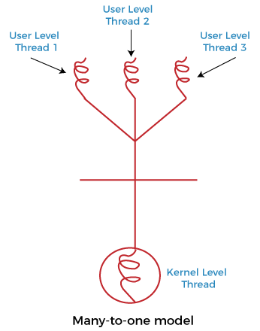
In the above figure, the many to one model associates all user-level threads to single kernel-level threads.

One to one multithreading model
The one-to-one model maps a single user-level thread to a single kernel-level thread. This type of relationship facilitates the running of multiple threads in parallel. However, this benefit comes with its drawback. The generation of every new user thread must include creating a corresponding kernel thread causing an overhead, which can hinder the performance of the parent process. Windows series and Linux operating systems try to tackle this problem by limiting the growth of the thread count.
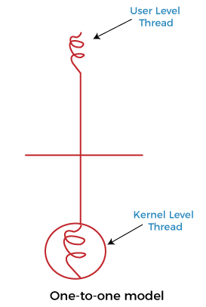
In the above figure, one model associates that one user-level thread to a single kernel-level thread.

Many to Many Model multithreading model
In this type of model, there are several user-level threads and several kernel-level threads. The number of kernel threads created depends upon a particular application. The developer can create as many threads at both levels but may not be the same. The many to many model is a compromise between the other two models. In this model, if any thread makes a blocking system call, the kernel can schedule another thread for execution. Also, with the introduction of multiple threads, complexity is not present as in the previous models. Though this model allows the creation of multiple kernel threads, true concurrency cannot be achieved by this model. This is because the kernel can schedule only one process at a time.
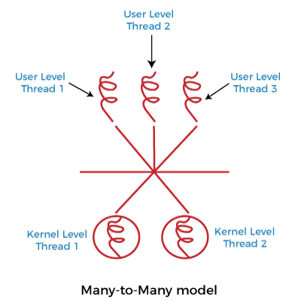
Many to many versions of the multithreading model associate several user-level threads to the same or much less variety of kernel-level threads in the above figure.

